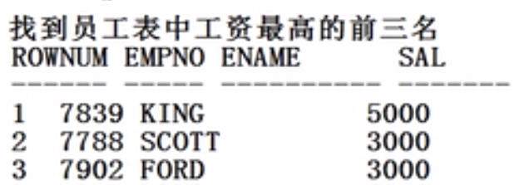

(要提升权限：

1.Conn / as sysdba 2. Grant create view to scott 3.重新以scott登入)

Create view sal_view as select * from emp order by sal desc;

Select rownum ,sal_view .* from sal_view where rownum<=3;

标准答案：

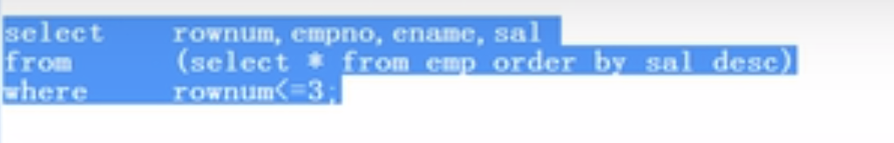

Select rownum,empno,ename,sal from (select * from emp order by sal desc) where rownum<=3;

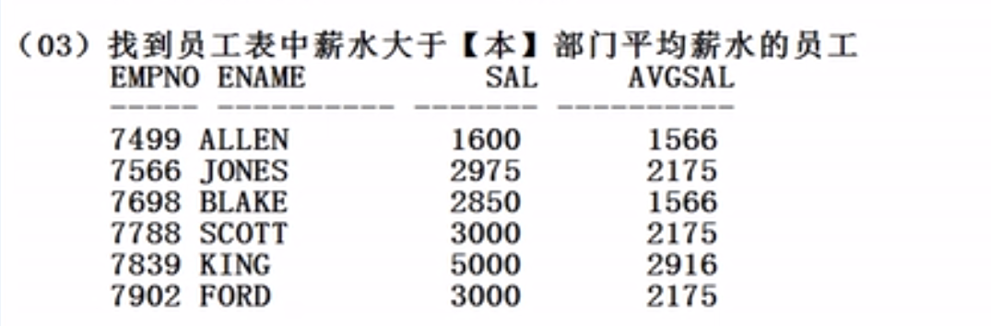

Select deptno,round(avg(sal),0) from emp group by deptno;==》这个作为虚表

**(在Oracle在使用group by 必须非常小心，最好和聚合函数一同出现在一个语句中，否则容易出错)**

**完整实现:**

***Select emp.empno,emp.ename,emp.sal,xx.avgsal from emp, (Select deptno,round(avg(sal) ,0) avgsal from emp group by deptno) xx where (emp.deptno=xx.deptno) and (emp.sal>xx.avgsal);* 难度很大，多表查询，真表和虚表**

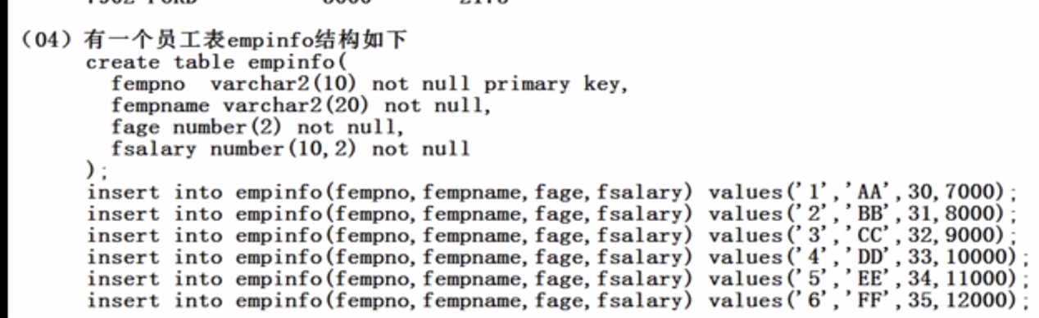

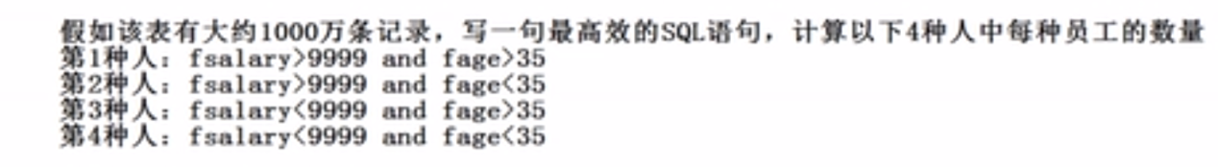

Create table empinfo(

Fempno varchar2(10) not null primary key,

Fempname varchar2(20) not null,

Fage number(2) not null,

Fsalary number(10,2) not null

);

Insert into empinfo(fempno,fempname,fage,fsalary) values(**'1', 'xiaoming',30,7000**);

Insert into empinfo(fempno,fempname,fage,fsalary) values(**'2', 'xiaoming',31,8000**);

Insert into empinfo(fempno,fempname,fage,fsalary) values(**'3', 'xiazhu,32,9000**);

Insert into empinfo(fempno,fempname,fage,fsalary) values(**'4', 'xiaohong',33,10000**);

Insert into empinfo(fempno,fempname,fage,fsalary) values(**'5', 'xiaoli',34,11000**);

Insert into empinfo(fempno,fempname,fage,fsalary) values(**'6', 'xiaoxu',35,12000**);

Insert into empinfo(fempno,fempname,fage,fsalary) values(**'7', 'xiaobi',36,13000**);

Insert into empinfo(fempno,fempname,fage,fsalary) values(**'8', 'xiaobo',37,14000**);

实现

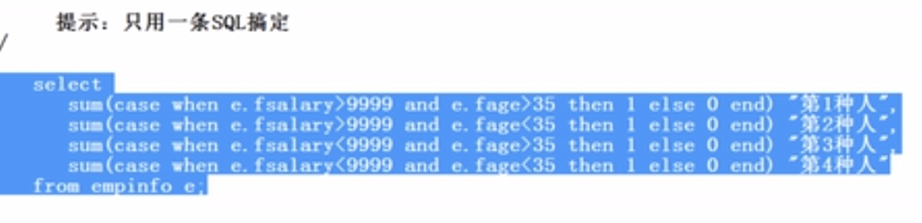

**Select**

**Sum(case when e.fsalary>9999 and e.fage>35 then 1 else 0 end) “第一种人”,**

**Sum(case when e.fsalary>9999 and e.fage<35 then 1 else 0 end) “第二种人”,**

**Sum(case when e.fsalary<9999 and e.fage>35 then 1 else 0 end) “第三种人”,**

**Sum(case when e.fsalary<9999 and e.fage<35 then 1 else 0 end) “第四种人”**

**From empinfo e;**



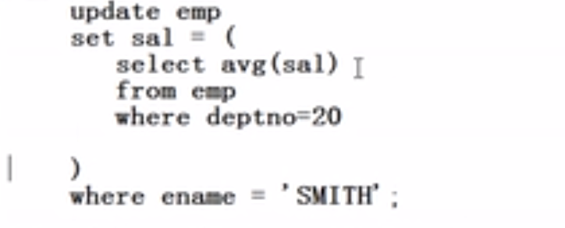

**Update emp set sal=(select avg(sal) from emp where deptno=20) where ename= 'SMITH';**



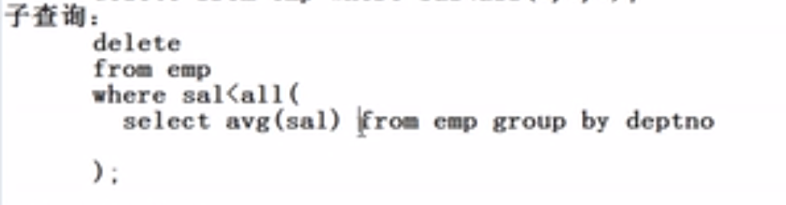

**Delete from emp where sal< all (select avg(sal) from emp group by deptno);**

**注意：如果没有输入commit或者退出命令行界面，随时都可以用roll back 和commit恢复数据**